User's Guide for Reynward Incredimail Converter (v0.21)

Background to an Incredimail Database
There are two data files to an Incredimail database. The first data file is where all the email messages are stored. This data file or database file has an extension of .imm. The second data file is the header file, where some information is kept, such as the sender, receiver, subject, etc. The header file has an extension of .imh. Each Incredimail folder is named and composed of these two data files. See page 5 (Appendix A) for the location of the Incredimail databases and attachments.

Using the Converter
Below is a screen shot of the Reynardware Incredimail Converter.
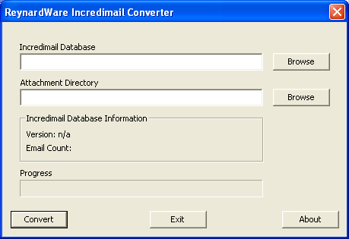Illustration 1: Screen Shot of the Converter
To start converting an incredimail database, the converter needs three things: the Incredimail database, header file, and the attachment directory. See below.
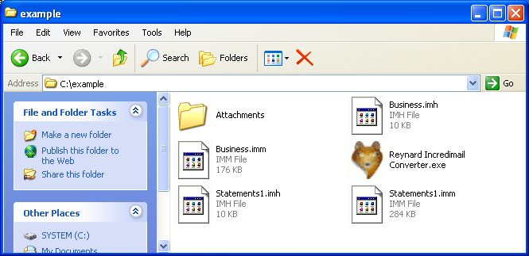Illustration 2: Setup before converting
In the example directory there is an attachments directory and Incredimail folders called Business and Statements1. As mentioned in the Background section, the Incredimail folders are composed of two data files. For example, the folder Business is composed of the two data files called Business.imm and Business.imh. To selected a database the user can either enter the full path in the first line or click on the first “Browse” button. When the user clicks on the “Browse” button a “Open Incredimail Database File” window will open. See Illustration below.
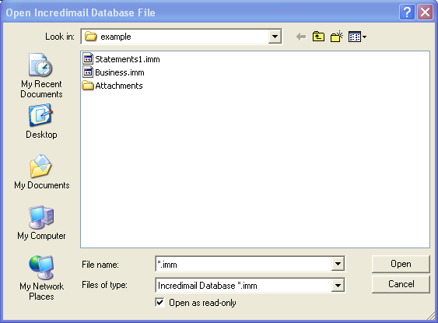Illustration 3: Open a Incredimail database file
The user should select a .imm file or the data file. Once the user selects the data file, the converter will automatically try to open the corresponding .imh file or header file in the same directory. It will also display information about the database in the “Incredimail Database Information” area of the converter. If the converter can not find the header file, it will display a warning message.
Once the data and header file is selected, the attachment directory must be selected. The user can either enter the full path in the second line or click on the second “Browse” button to the select the Incredimail attachment directory.
Now that the database and attachment directory is selected, the converter should look like the example below.
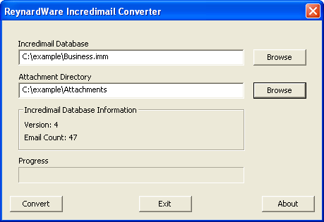Illustration 4: Database ready to be converted
The user can now click the “Convert” button. The progress bar will increase with each email it converts. When completed, the converter will display “Done!” See Illustration 5: Converter Completed.
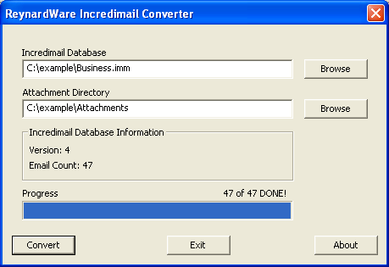Illustration 5: Converter Completed
A new folder, named as the data files, with the corresponding .eml files will be in the same location as the data files. In “Illustration 6: Example of the Business Conversion Complete“ and “Illustration 7: Newly created Business folder with .eml files“ the folder Business was created when the conversion was completed.
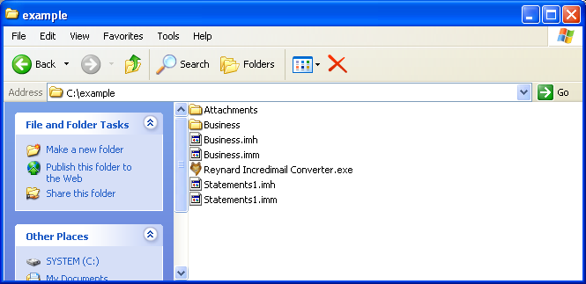Illustration 6: Example of the Business Conversion Complete
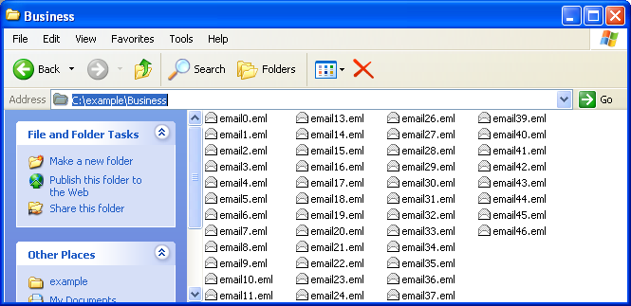Illustration 7: Newly created Business folder with .eml files

Limitations of the Reynard Incredimail Converter
There is only one known limitation, which the converter will only convert Incredimail Databases of version 4 and 5. If the converter does not know the version of the database, it will display a warning message. Please note: Converting an unknown database format will produce unexpected results.

Acknowledgments
The Reynard Incredimail Converter icon was taken from Lothar Grimme (Carpelinx package) from http://www.iconfinder.net. This icon is licensed as GPL. The GPL text can be found in this package.

Problems, Comments, or “Thanks!”
If you have any problems, comments, or a simple “Thank you!” Please email Reynardware@gmail.com

Appendix A – Where to find the Incredimail datafiles and Attachments
The easiest way to locate the data files and attachment directory is by going into Incredimail and by selecting Tools->Options. On the General tab click on the data folder. This will bring up a window with the location of the data files and attachment directory. The default location is C:\Document and Settings\<USER>\Local Settings\Application Data\IM, where <USER> is the windows account login. Please note that you need to show hidden directories to see the data file directories.

Appendix B – Revisions
v0.21 2009-04-14
- Corrected a major bug in the offset routine. See Issue #2 for details.
- Added a percentage complete at the bottom
- Updated user manual

v0.2 2009-04-12
- Created a thread for the converting.
- Added an fox icon
- Created a delete function which take cares of the temporary directory
- Much better error handling
- Added information on the database file

v0.1 2009-04-06
Initial Version! Just want to get the source and project built so the public can start using the converter.

